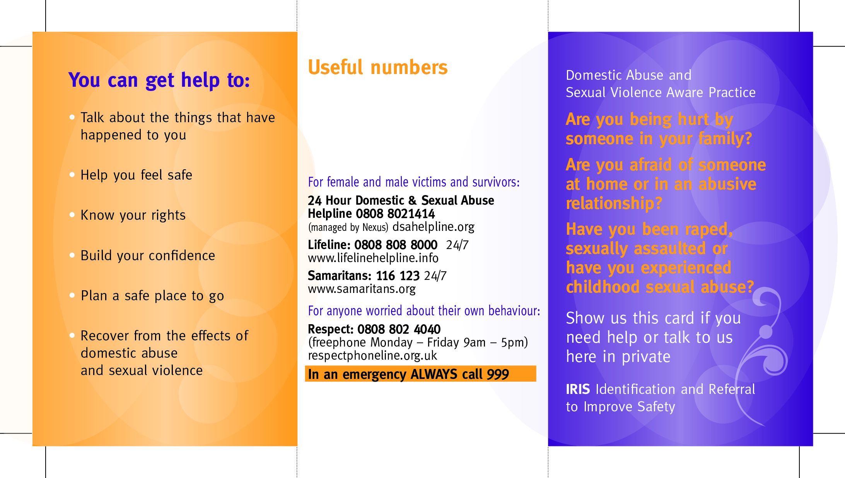­

**Speak to your GP or a member of the GP practice staff or call;**

**IRIS Worker: *Kimberley***

**028 9066 6049**

**07707290442**

